# Activity: Faunal Analysis

Imagine you are an archeologist working at another 19th-century plantation site. During your excavations you uncover many animal bones. You wish to know how the people living on the site obtained their food.

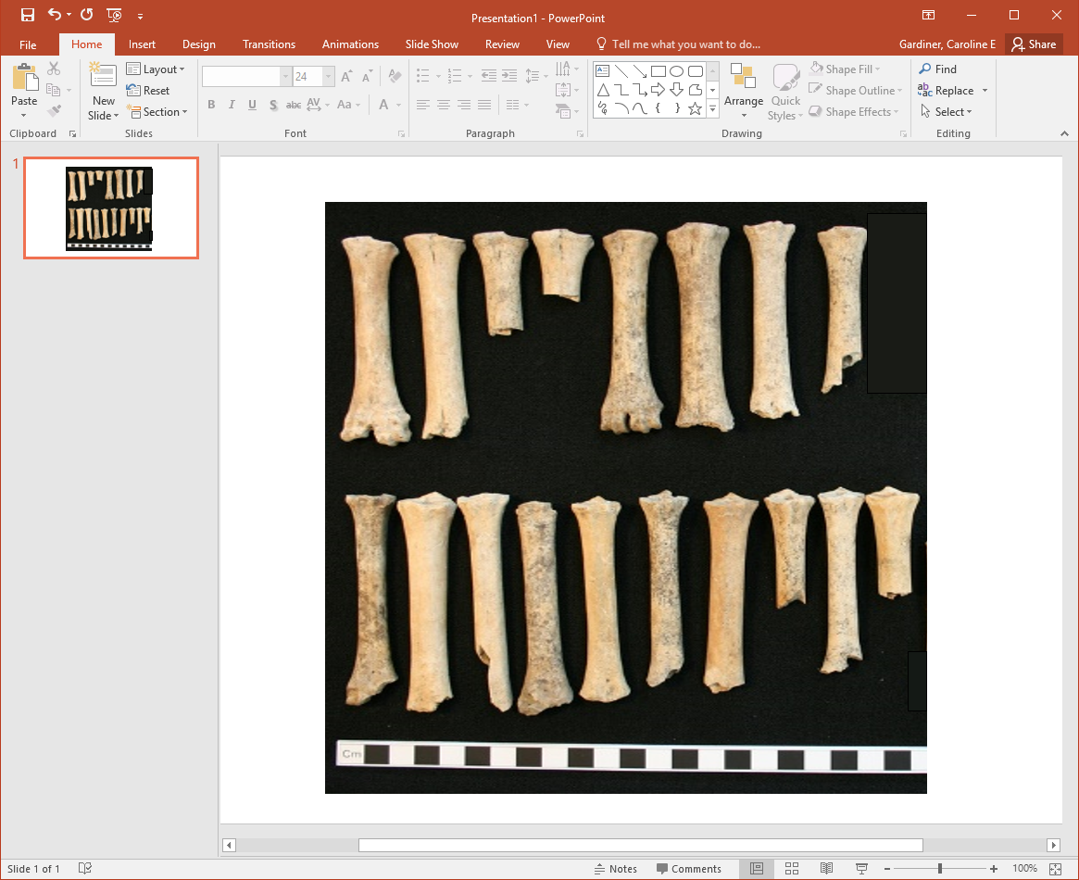

Sheep bones. Museum of London.

**Question 1)** You find multiple sheep bones on one area of the site. You identify both left femurs (top) and right femurs (bottom). Use these bones to find the NISP and MNI values. Explain why these numbers differ.

**Question 2)** At another area, you excavate bones from many species. You analyze all of the excavated bones and find the following:

| **Species** | **NISP** | **MNI** |
| --- | --- | --- |
| Chicken | 4 | 4 |
| Cow | 6 | 1 |
| Deer | 8 | 1 |
| Fish | 21 | 3 |
| Fox | 1 | 1 |
| Sheep | 14 | 5 |
| Horse | 6 | 1 |
| Mouse | 29 | 10 |
| Pig | 11 | 7 |
| Rabbit | 20 | 3 |
| Rat | 2 | 1 |
| Turtle | 35 | 2 |

Based on the species you see, what do you think the environment around the site looked like? How does that information help you answer your research question?

**Question 3)** Identify the five species with the highest NISP values. Based on your answer, what do you think was the main method people at this site used to obtain their food?

Make a second list of the five species with the highest MNI values. Compare these results to the NISP values. Do any species appear on both lists? How does the MNI result change your original interpretations?

What other evidence might archeologists find that would help decide which interpretation was more accurate? Be creative.